**PUBLISH THE MESSAGE WITH QUEUE**

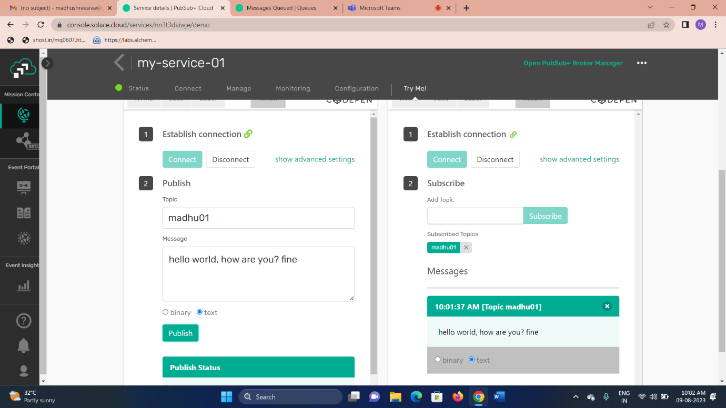

**QUEUES**

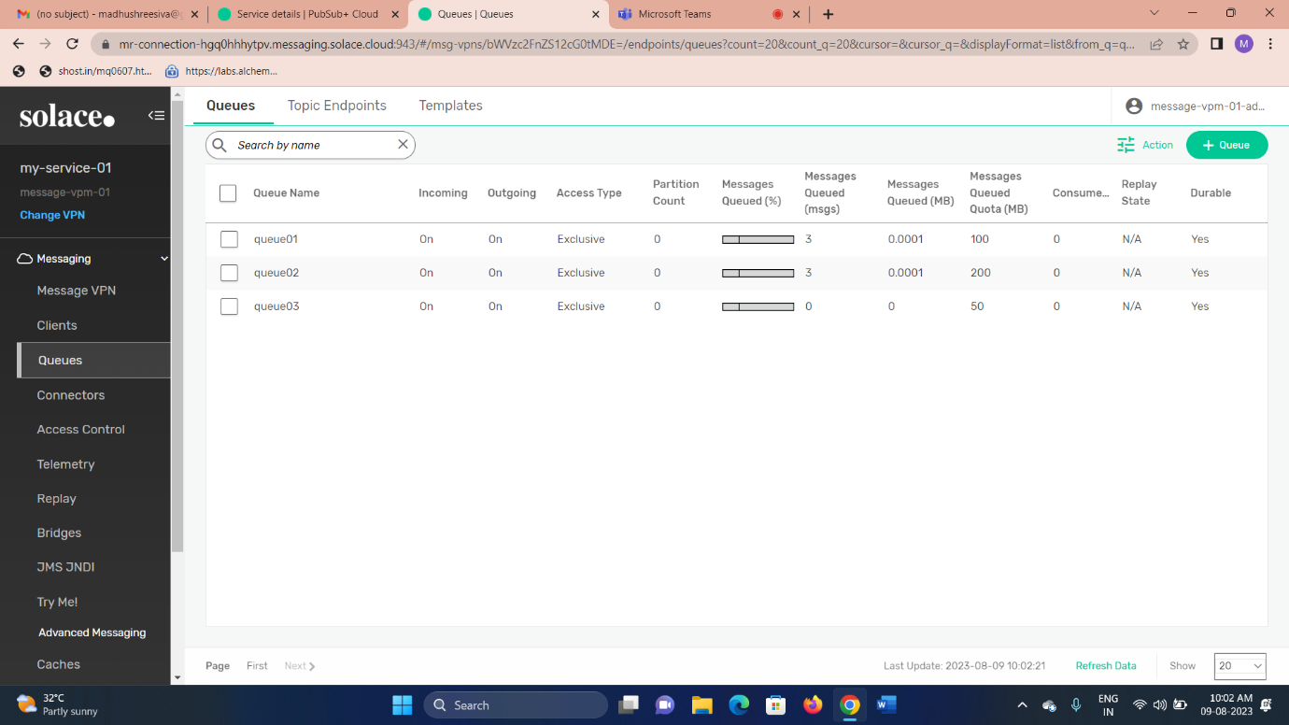

**SUBSCRIPTIONS**

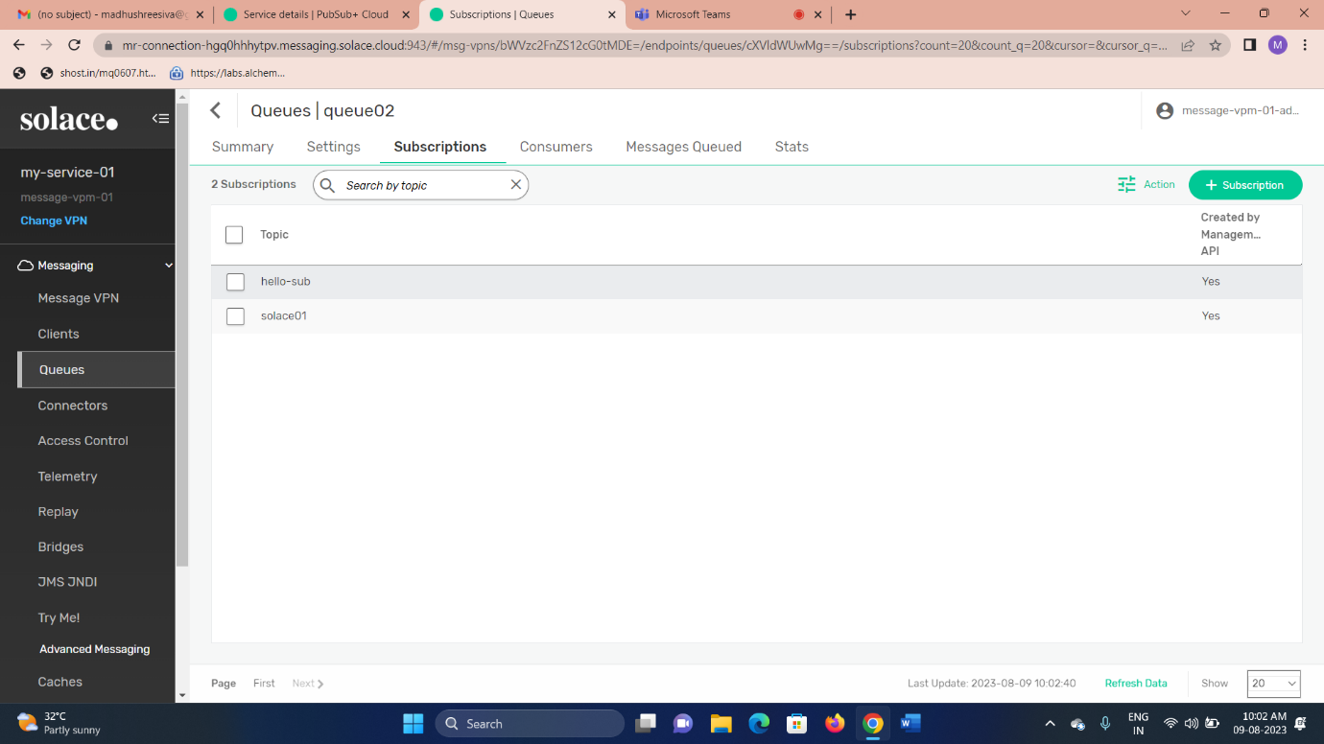

**MESSAGE QUEUED**

